Super Sessions: 4 New Must-Try’s at School of Play!

Market Research:

Here are 10 facts and statistics about the importance of unique sports for kids, all sourced with links:
- Unique Sports Encourage Higher Self-Esteem
A study revealed that children participating in non-traditional sports like parkour and rock climbing reported a 20% higher increase in self-esteem than those in traditional sports.
Source: ResearchGate
- Improved Social Skills in Unique Sports
78% of youth in activities like skateboarding and parkour reported better peer interactions due to non-competitive settings.
Source: PHRP
- Physical Fitness and Engagement
Programs focused on alternative sports saw a 30% increase in physical activity levels among kids aged 8-12 compared to traditional programs.
Source: MDPI
- Mental Health Benefits
Children participating in adventure sports such as climbing or hiking displayed a 25% reduction in anxiety symptoms over six months.
Source: Springer
- Higher Retention Rates in Unique Sports
Kids enrolled in activities like parkour were 40% more likely to continue sports participation into adolescence.
Source: Elsevier
- Enhanced Problem-Solving Skills
Participation in strategic sports like rock climbing improved problem-solving abilities by 15%, measured through cognitive skill assessments.
Source: Springer
- Social Equality Opportunities
Non-traditional sports foster inclusivity, with 62% of participants in skateboarding programs identifying as from underserved communities.
Source: MDPI
- Cross-Disciplinary Benefits
Kids in unique sports were found to have a 10% better academic performance compared to peers in standard sports, attributed to the innovative challenges they face.
Source: PHRP
- Creative Thinking Boost
Parkour participants demonstrated a 22% improvement in creative thinking scores after six months of regular practice.
Source: ResearchGate
- Long-Term Health Advantages
Children engaging in climbing or yoga retained a 30% lower body mass index (BMI) and better joint health over five years compared to their peers.
Source: Elsevier
These sources highlight the comprehensive benefits of unique sports in promoting physical, mental, and social development among children. Let me know if you need additional details!

Campaign Aim:
The goal of this campaign is to showcase our four exciting, innovative SUPER activities—Glow-in-the-Dark Dodgeball, Remote Control Car Racing, Laser Tag, and Mini Golf. These unique offerings highlight our commitment to creating standout experiences that set us apart from traditional, generic sports camps.
We want parents to see the value of choosing SOP as the ultimate destination for fun, engaging, and memorable activities that go beyond standard sports. By emphasising the creativity and exclusivity of our programs, we aim to position SOP as the leading choice for families looking for an extraordinary sports camp experience that prioritizes innovation, excitement, and unforgettable moments.
SMART Goal:

Audience: Achieve a 25% increase in sports group registrations compared to the same period last year & also compare last two camps as well.

Parents (mainly female), aged 34-44, who value family life and are looking for quality sports provisions that differs from competitors.

Blog:

5 Reasons Why Non-Traditional Sports Are Super Important for Children
At SOP, we're redefining FUN with unique, game-changing activities like Glow-in-the-Dark Dodgeball, Remote Control Car Racing, Laser Tag, and Mini Golf. Why settle for ordinary when extraordinary is an option?
Here’s why non-traditional sports are a slam dunk for your child’s development—and why SOP is the ultimate destination for inspiring Active Bodies and Active Minds!

1. 📚 Boost Brains and Confidence
Research shows kids involved in unique sports are 20% more likely to achieve higher self-esteem and improved problem-solving abilities. Whether it’s aiming for the perfect dodgeball glow shot or solving mini-golf puzzles, these activities sharpen minds and build confidence like pros.
(Source: ResearchGate, Springer)
https://www.researchgate.net/

2. 🤝 Stronger Friendships & Social Wins
78% of kids in activities like parkour and skateboarding report better peer interactions thanks to their non-competitive, inclusive nature. SOP’s team-based Laser Tag and Remote-Control Car Racing are perfect for sparking teamwork and laughter.
(Source: PHRP)
https://www.phrp.com.au/wp-content/uploads/2021/06/PHRP30122006.pdf

3. 🌟 Inclusivity Meets Creativity
Our unique sports promote inclusivity, with 62% of participants in alternative sports like skateboarding identifying as from underserved communities. SOP’s creative games ensure everyone feels welcome because fun knows no limits.
(Source: MDPI)
https://www.mdpi.com/1660-4601/19/14/8597

4. 💡 Active Play = Happy Minds
Say goodbye to screen time and hello to better mental health. Kids in adventure sports like climbing and hiking show a 25% reduction in anxiety symptoms, proving that active play strengthens both body and mind.
(Source: Springer)
https://link.springer.com/article/10.1186/1479-5868-10-98

5. 🚀 Ready for Lifelong Adventures
Kids engaged in unique sports are 40% more likely to stay active into adolescence, paving the way for a lifelong love of movement. SOP’s new WOW Activities ignite a passion for fitness that lasts a lifetime.
(Source: Elsevier)
https://www.sciencedirect.com/science/article/abs/pii/S1469029211000744
At SOP, ordinary is just not our style. From reducing anxiety to building lasting friendships, our programmes are designed to help your child thrive.
So, are you ready to score some seriously SUPER Sessions this year?
Sign up for SOP’s next sports camps here!
[Get Flyer Done for the taster Day]
[Holiday Camp Booking]

SUPER Sessions Taster Day Details

- 4 Sports Coaches (Including Sean) + Ash & Ryan

- Date: 3rd OR 10th May 2025

- Time: 9am - 12pm

- Location: ?? Hire a sports hall (preferably with a café for parents)

- Host Glow in the Dark Dodgeball (May have to hire an extra space for this in the sports hall), Laser Tag, RC Car Racing & Mini Golf on rotation.

- Only 30 spots available (5 aside for Dodgeball & Laser Tag – Two teams play twice), 5 on RC Car Course and 5 on mini-golf)

- Give out flyers for Whit Half-Term, brochures and a ‘10% discount voucher when you book onto Multi-Sport Marvels’ for Whit’.

- Make 2 Microsoft ‘Expression of Interest’ & ‘Booking’ form with the details- make sure to include PHOTO CONSENT to the booking form.

[Green] = Needs Content | [Yellow] = Needs a CTA Link | [Red] = Needs Actioning | Purple Text =

Content Plan + Copy

Email 1: 4th March
Email 2: 11th March
Email 3: 18th March
Email 4: 25th March

Email 5: 2nd April
Email 6: 8th April (9th April is the Easter Camp)
Email 7: 15th April
Email 8: 22nd April

Email 9: 3rd OR 10th May (1PM)

EMAILS

Email 1: Initial Expression of Interest (Whisper Phase)
Subject Line: [Name], interested in a SUPER Sessions Taster Day?
Preview Text: [FREE Taster Sessions]
A/B TEST (Blue Button):  Hey [Name],  Quick Question…  Would you be interested in an exclusive SUPER Sessions Taster Day! It would be the perfect chance to experience all four of our new activities on one unforgettable Saturday morning, making you activity provider decisions a BREEZE!  [I’m Interested!] [Make Expression of Interest Form]  Need More?  Ever think, “why should I choose their Sports Programmes over others? Surely, there can’t be THAT much difference!”?  Let us tell you WHY! School of Play are redefining children’s perspective on sports by introducing non-traditional sessions like:  Glow-in-the-Dark Dodgeball  ️ Remote-Control Car Racing  Laser Tag  ️ Mini Golf  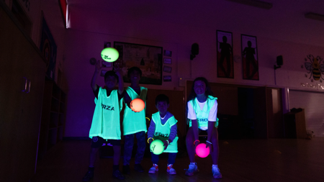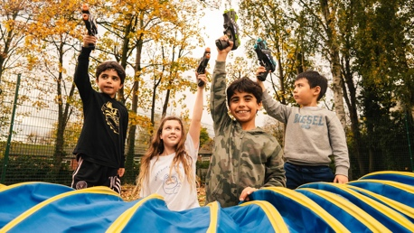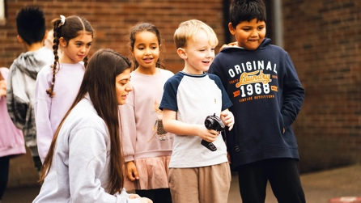  These SUPER Sessions go beyond the ordinary to ignite passion and imagination in every child, no matter their interests! | A/B TEST (Red Button):  Hey [Name],  Quick Question…  Would you be interested in an exclusive SUPER Sessions Taster Day! It would be the perfect chance to experience all four of our new activities on one unforgettable Saturday morning, making you activity provider decisions a BREEZE!  [I’m Interested!] [Make Expression of Interest Form]  Need More?  Ever think, “why should I choose their Sports Programmes over others? Surely, there can’t be THAT much difference!”?  Let us tell you WHY! School of Play are redefining children’s perspective on sports by introducing non-traditional sessions like:  Glow-in-the-Dark Dodgeball  ️ Remote-Control Car Racing  Laser Tag  ️ Mini Golf  These SUPER Sessions go beyond the ordinary to ignite passion and imagination in every child, no matter their interests!

Email 2: Build Anticipation OR Invite (Depending on Interest) (Tease Phase)
Subject Line: We’ve had X interested parties…
Preview Text: ️ Save the Date: Our Super Sessions Taster Day…
A/B TEST (Blue Button):  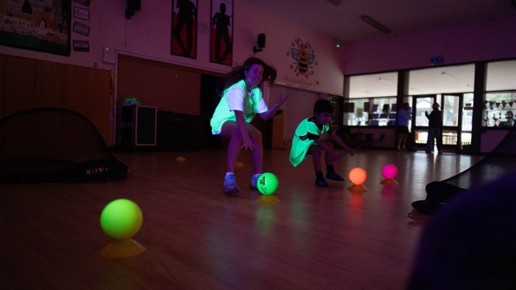  🌟 Imagine your child:  - Glowing with excitement at Glow-in-the-Dark Dodgeball  - Racing RC cars like a pro driver  - Burning their excess energy with Laser Tag  - Acing tricky mini-golf shots  Want to see it live? Join us at the SUPER Sessions Taster Day.  📅 Save the date: Saturday [insert date] Venue: ---! [Google Calendar link] [Make Link]  (If there WASN’T a lot of interest in the first email)  [I’m Interested!] [Make Expression of Interest Form]  OR  (If there WAS a lot of interest in the first email)  [Reserve Your FREE Spot]  (Only 30 spots available) | A/B TEST (Yellow Button):  🌟 Imagine your child:  - Glowing with excitement at Glow-in-the-Dark Dodgeball  - Racing RC cars like a pro driver  - Burning their excess energy with Laser Tag  - Acing tricky mini-golf shots  Want to see it live? Join us at the SUPER Sessions Taster Day.  📅 Save the date: Saturday [insert date] Venue: ---! [Google Calendar link] [Make Link]  (If there WASN’T a lot of interest in the first email)  [I’m Interested!] [Make Expression of Interest Form]  OR  (If there WAS a lot of interest in the first email)  [Reserve Your FREE Spot]  (Only 30 spots available)

Email 3: Official Invite to the Taster Day (Shot Phase)
Subject Line: [Official Invite] Super Session Taster Day Invitation!
Preview Text: Glow-in-the-Dark Dodgeball, RC Car Racing, Laser Tag + Mini Golf!
A/B TEST (Yellow Button):  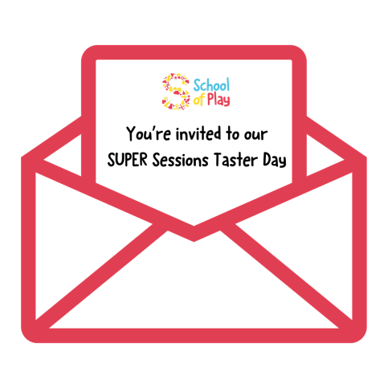  Get ready for an unforgettable morning of action and excitement! SOP’s SUPER Sessions Taster Day is a chance for your child to experience:  ✅ Glow-in-the-Dark Dodgeball  ✅ RC Car Racing  ✅ Laser Tag  ✅ Mini Golf  📅 Date: Saturday [insert date]  🕘 Time: [insert time]  📍 Location: [Insert location details]  ️ During the activities: Feel free to use the onsite café to grab a bru!  [Reserve Your FREE Spot]  (Only X spots available) | A/B TEST (Red Button):  Get ready for an unforgettable morning of action and excitement! SOP’s SUPER Sessions Taster Day is a chance for your child to experience:  ✅ Glow-in-the-Dark Dodgeball  ✅ RC Car Racing  ✅ Laser Tag  ✅ Mini Golf  📅 Date: Saturday [insert date]  🕘 Time: [insert time]  📍 Location: [Insert location details]  ️ During the activities: Feel free to use the onsite café to grab a bru!  [Reserve Your FREE Spot]  (Only X spots available)

Email 4: Social Proof & Benefits (Informative Tease)

A/B TEST (Statement):  Subject Line: 5 Reasons Why Non-Traditional Sports Are Super Important for Children  Preview Text: The future looks fun! | A/B TEST (Question):  Subject Line: 5 Reasons Why Non-Traditional Sports Are Super Important for Children  Preview Text: The future looks fun!



In light of our ‘SUPER Sessions Taster Day’, we have done a little digging…

Read our recent blog post, ‘5 Reasons Why Non-Traditional Sports Are Super Important for Children’.
[Read Now]
Did you know? Kids in unique sports like ours report:
- 20% higher confidence
- 78% stronger peer connections
- 25% reduced anxiety

Still interested in our ‘SUPER Sessions Taster Day’?
[Reserve Your FREE Spot Here]
(Only X spots available)

Email 5: Photo-Focused Email
A/B TEST (Statement):  Subject Line: “Otis is learning lots of different sports”  Preview Text: What others are saying! | A/B TEST (Question):  Subject Line: “Otis is learning lots of different sports”  Preview Text: What others are saying!
[Name], picture this…
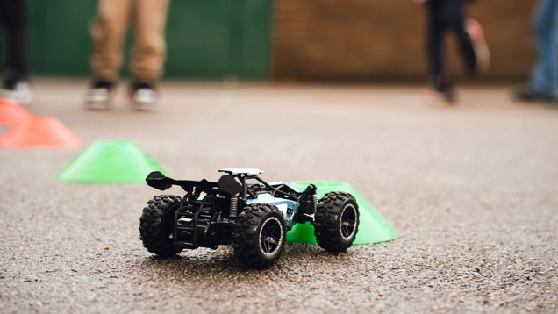
💬 “I really love that my daughter gets to try sports she doesn’t have the opportunity to do elsewhere.” - Danielle McCabe (Parent from Urmston camp)
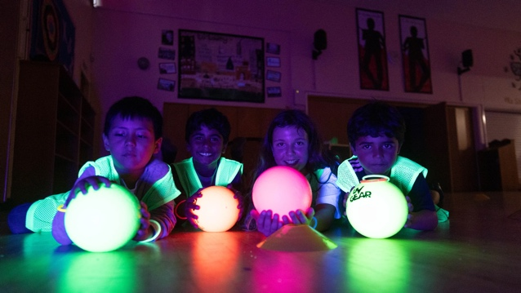
“Otis is learning lots of different sports and games that he comes home and wants to play.” - Katie Gardiner (Parent from Chorlton camp)
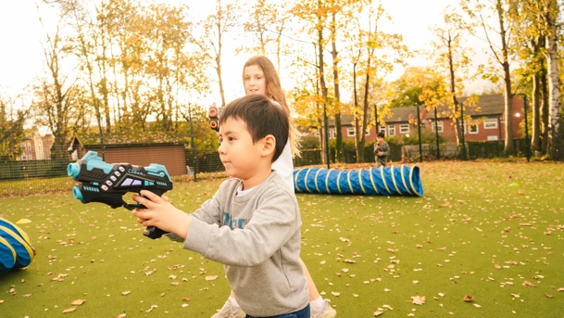
“There were lots of different activities, and my daughter never got bored! The ideas were very creative.” - Claudia Mendonca (Parent from Chorlton camp)
✨ Be SUPER. Join us at our Taster Day full of potential new favourites!
[Reserve Your FREE Spot Here]
(Only X spots available)

OR
Subject Line: You Have to Try This! 🌟
Header: What Did [Pending Name] Think About Glow-in-the-Dark Dodgeball?
KIDS SAY IT BEST
We’ve added four incredible new Super Sessions to our line-up—and Glow-in-the-Dark Dodgeball is already a favourite at our Before and After school Clubs!
Don’t just take it from us or even from other parents—here’s what the KIDS have to say:
"[Testimonial]”
It’s action-packed, full of excitement, and an experience your child won’t stop talking about.
Spots are limited book you’re a taster session now!
[Reserve Your Spot Today]

Email 6: Deep Dive
A/B TEST (Statement):  Subject Line: [Your FREE Gift]  Preview Text: [Name], you’ll love this! | A/B TEST (Question):  Subject Line: [Your FREE Gift]  Preview Text: [Name], you’ll love this!
(What will be in the PDF Download)
https://www.schoolofplay.org.uk/wp-content/uploads/2024/12/Incentives-PDFs-1.pdf
Get ready to explore the exciting world of School of Play’s SUPER Sessions! We’ve created a handy guide detailing our unique activities and their incredible benefits for kids.
[Download Your Guide Now]
See how each activity can boost confidence, build teamwork, and inspire creativity in your child!

Email 7: Easter Camp highlights with SUPER Sessions (Friendly Tone)
Subject Line: [Name], Here’s What Your Kids Loved! 🌟
Preview Text: Check out the highlights here…
A/B TEST (White Background):  What an amazing Easter Camp we’ve had so far with a special mention of our SUPER Sessions that have been AWESOME.  From Glow-in-the-Dark Dodgeball to Laser Tag Battles, our activities brought out the best in every child.  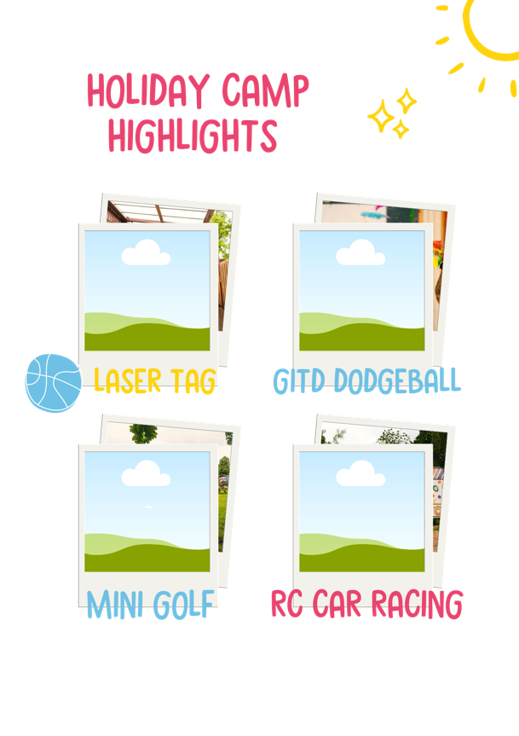  [Images need inserting]  Did you know? Our SUPER Sessions are now part of every SOP holiday camp! Whether it’s mastering mini golf or racing remote-control cars, there’s something for every child to love.  [Whit half-Term - Early Bird Bookings]  [Images of Whit Flyer] | A/B TEST (Blue Background):  What an amazing Easter Camp we’ve had so far with a special mention of our SUPER Sessions that have been AWESOME.  From Glow-in-the-Dark Dodgeball to Laser Tag Battles, our activities brought out the best in every child.  [Images need inserting]  Did you know? Our SUPER Sessions are now part of every SOP holiday camp! Whether it’s mastering mini golf or racing remote-control cars, there’s something for every child to love.  [Whit half-Term - Early Bird Bookings]  [Images of Whit Flyer]

Email 8: Final Call (Scarcity Focus)
Subject Line: Final Call: SuperSport Taster Day
Preview Text: We have X spots left available…
A/B TEST (White Background):  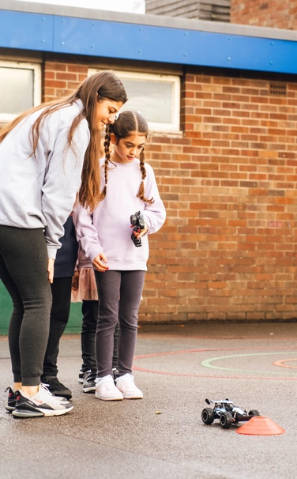  This is it! Only a few spots remain for SOP’s SUPER Sessions Taster Day.  Detail Reminders:  📅 Date: Saturday [insert date]  🕘 Time: [insert time]  📍 Location: [Insert location details]  ️ During the activities: Feel free to use the onsite café to grab a bru!  Activities:  ✅ Glow-in-the-Dark Dodgeball  ✅ RC Car Racing  ✅ Laser Tag  ✅ Mini Golf  [Reserve Your FREE Spot]  (Only X spots available) | A/B TEST (Red Background):  This is it! Only a few spots remain for SOP’s SUPER Sessions Taster Day.  Detail Reminders:  📅 Date: Saturday [insert date]  🕘 Time: [insert time]  📍 Location: [Insert location details]  ️ During the activities: Feel free to use the onsite café to grab a bru!  Activities:  ✅ Glow-in-the-Dark Dodgeball  ✅ RC Car Racing  ✅ Laser Tag  ✅ Mini Golf  [Reserve Your FREE Spot]  (Only X spots available)

Email 9: Post-Event Follow-Up- Only send to the people who attended.
Subject Line: [Name], enjoy your morning?
Preview Text: TELL US MORE
A/B TEST (Red Background):  [Leave a Review]  [Images from the event] [Need to get pictures]  Thank you for making our SUPER Sessions Taster Day a roaring success!  We hope your kids discovered something new and enjoyed every moment. Please share you’re experience with us; we’d love to hear it!  [Images of Whit Flyer]  Ready for more? Enrol your child onto our upcoming Whit Half-Term Holiday Camp today and experience the perfect mixture of traditional sports and ‘WOW’ sessions!  [Secure a Spot]  [Specific Venue Dates] | A/B TEST (Blue Background):  [Leave a Review]  [Images from the event] [Need to get pictures]  Thank you for making our SUPER Sessions Taster Day a roaring success!  We hope your kids discovered something new and enjoyed every moment. Please share you’re experience with us; we’d love to hear it!  [Images of Whit Flyer]  Ready for more? Enrol your child onto our upcoming Whit Half-Term Holiday Camp today and experience the perfect mixture of traditional sports and ‘WOW’ sessions!  [Secure a Spot]  [Specific Venue Dates]
A/B Testing for WOW Sports Campaign

What is being tested? | Results
Email 1 – Colour of CTA Button
Email 2 – Colour of CTA Button
Email 3 – Colour of CTA Button
Email 4 – Question or Statement in the Subject Line
Email 5 – Question or Statement in the Subject Line
Email 6 – Question or Statement in the Subject Line
Email 8 – Colour of email Background
Email 9 – Colour of email Background
Email 10 – Colour of email Background

Social Copy

Insta Post 1: 3rd March
Insta Post 2: 11t^{h} March
Insta Post 3: 19t March
Insta Post 4: 27^{h} March
Insta Post 5: 4th April

Facebook Post 1: 4th^{h} March
Facebook Post 2: 12^{h} March
Facebook Post 3: 18^{h} March
Facebook Post 4: 28th^{st} March
Facebook Post 5: 3rd Feb

LinkedIn Post 1: 11th March
LinkedIn Post 2: 28th March
LinkedIn Post 3: 1st Ar

Instagram Captions
- 🚀 Let’s get SUPER! 🌟 Introducing our SUPER Sessions Taster Day, featuring Glow-in-the-Dark Dodgeball, RC Car Racing, Laser Tag, and Mini Golf.
Only 30 spots—secure your child’s today!
[Link in bio] #SchoolOfPlay #ActivityDays #SuperSessions
- 🏀🎨 Mini Golf, Laser Tag, and more! Our SUPER Sessions Taster Day is where fun meets adventure.
Don’t miss this exclusive chance to experience it all. [Book Now]
#KidsActivities #GlowInTheDarkFun #ParentingSimplified
- 🌟 “Why choose SOP’s sports programmes?”
Because we’re redefining sports and childcare! From creativity to competition, it’s all here. Join our Taster Day to see the difference!
[Limited spots available!] #ActivityProvider #ChildhoodAdventures
- 🔫🚗 Ready, set, play! RC Cars, Laser Tag, and Dodgeball await your kids at our one-of-a-kind Taster Day.
Give them a morning they’ll never forget! [Reserve now]
#SuperSessions #ParentingWins #SchoolOfPlay
- 🏅 FINAL CALL! Only a few spots left for our SUPER Sessions Taster Day.
🌟 Unique activities, big smiles, unforgettable memories. Secure your place now!
[Link in bio] #ExclusiveFun #ChildhoodMagic

Facebook Captions
- 🚀 SUPER Sessions Taster Day is HERE! 🌟
Glow-in-the-Dark Dodgeball, Laser Tag, Mini Golf, and RC Car Racing—your child’s ultimate adventure is waiting.
📅 Choose from May 3rd or 10th.
Spots are limited—reserve your place today!
- 🌟 What makes SOP unique?
⚡ Glow-in-the-Dark Dodgeball
🚗 RC Car Racing
🔫 Laser Tag
⛳ Mini Golf
Join our FREE Taster Day and discover the magic of non-traditional sports!
- 🏀✨ Parents, say goodbye to boring weekends. Our SUPER Sessions Taster Day combines action, fun, and learning for kids of all interests.
Spaces are filling fast—secure your child’s spot today!
- 🏅 FINAL COUNTDOWN! Only a few spots left for our exclusive SUPER Sessions Taster Day.
🌟 Glow-in-the-Dark Dodgeball, Laser Tag, and more are waiting!
📅 Don’t miss out—book now!
- 🎉 Thank you to everyone who joined us at our SUPER Sessions Taster Day!
We loved sharing the magic of Glow-in-the-Dark Dodgeball, Laser Tag, and RC Racing. Stay tuned for our next exciting event!

LinkedIn Posts
1. Introducing SUPER Sessions: The Future of Fun 🚀

Our SUPER Sessions showcase the next level of engaging, non-traditional activities like Glow-in-the-Dark Dodgeball, RC Car Racing, Laser Tag, and Mini Golf.

These sessions are designed to captivate children’s imaginations, challenge their skills, and inspire creativity through play.

By offering unique, forward-thinking activities, we’re redefining what sports and childcare can be—creating exciting, inclusive experiences that benefit children and set new standards for innovation in activity provision.

#SchoolOfPlay #ActivityInnovation #FutureOfPlay

2. Why Non-Traditional Sports Matter 🌟

We’re redefining sports and childcare, and our recent blog explores why non-traditional sports are key to childhood development.

Read Now: https://www.schoolofplay.org.uk/5-reasons-why-non-traditional-sports-are-super-important-for-children/

#SchoolOfPlay #ChildhoodDevelopment #CreativeSports
3. Excitement Drives Engagement 🏀✨

Our SUPER Sessions Taster Day is designed to inspire—activities like RC Car Racing and Glow-in-the-Dark Dodgeball create a unique, energetic atmosphere.

This isn’t just about fun; it’s about innovation and engagement.

🌟 Why it’s important for your business:

- Keeps kids excited and returning for more.

- Reinforces creativity, teamwork, and resilience.

- Sets a new standard for childcare programmes.

Let’s work together to deliver forward-thinking experiences that benefit children and families alike.

#ActivityInnovation #EngagementInPlay #FutureOfChildcare

TikTok Ideas
- Behind-the-Scenes: A time-lapse of setting up Glow-in-the-Dark Dodgeball and RC Car Racing with upbeat music.
Caption: “Super prep for SUPER fun! 🚀🌟 [Reserve now in bio]”
- Parent POV: A parent watching their child’s excitement at Laser Tag, overlaid with the text: “This is why we choose SOP 💙”
Caption: “Moments like these make parenting a joy. Join us for SUPER Sessions! #GlowInTheDarkFun”
- Kids’ Voices: Snippets of kids saying what they loved most: “Dodgeball in the dark was AWESOME!”
Caption: “Hear it from the real experts! 🌟 [Book your spot now]”
- Countdown Video: A dramatic countdown overlayed with footage of each activity, ending with “Only 30 spots available!”
Caption: “The clock’s ticking! ⏳ Don’t miss the SUPER Sessions Taster Day. [Link in bio]”
- Challenge Reel: Kids competing in mini-golf or RC Racing with the hashtag #SuperChallenge.
Caption: “Who’s ready to take on the SUPER Sessions challenge? 🚀🎉 [Book now in bio]”

